Front and Back End

Front End:

* User Interface

Back End:

* Server
* Application
* database

Front end:

* HTML
* CSS
* Java script

Backend:

Server

* Provides data
* Does business calculations and logics
* DB-MySQL,No SQL,PostgresSQL

Languagues

Full Stack Developers

Front end + Back End

References:

<https://www.conceptatech.com/blog/difference-front-end-back-end-development>

Selenium components:

<https://www.youtube.com/watch?v=OWaJ7Iu4dHQ>

Web Driver:

1.Selenium Test script(java,python perl)

2.Json wire protocol

3.Browser Drivers (Chromedriver, firefox driver)

4.Browsers (Chrome, Forefox)

Web driver disadvantages:

* Cannot perform mobile automation
* Only sequential testing (no Parallel testing like Grid)
* Limited reporting capability
* Image testing

Good to have: Integrate with third party tools as alternative for above limitations

Web application :

<https://www.youtube.com/watch?v=d1Gd-MGaleE>

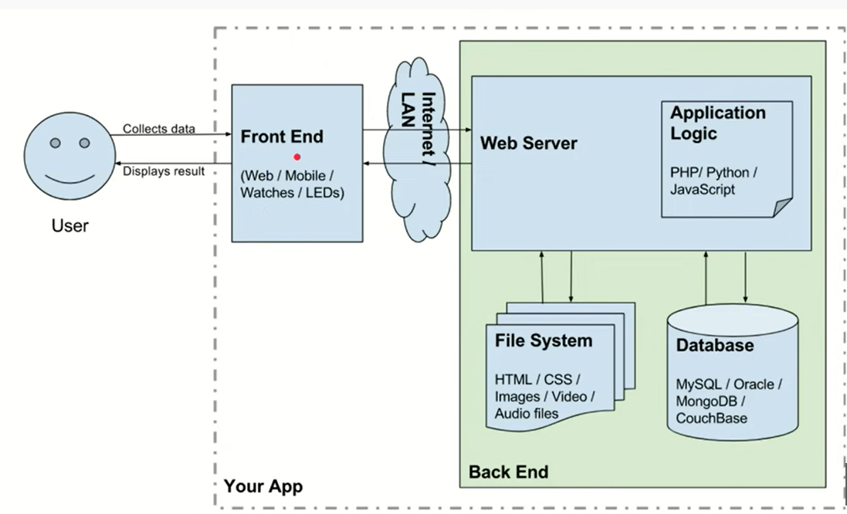

<https://www.youtube.com/watch?v=qDvkKXpIDSU> (Naveen automation )